**Assignment 1**

**Question 1:** Report view screen shot of Power BI Desktop.

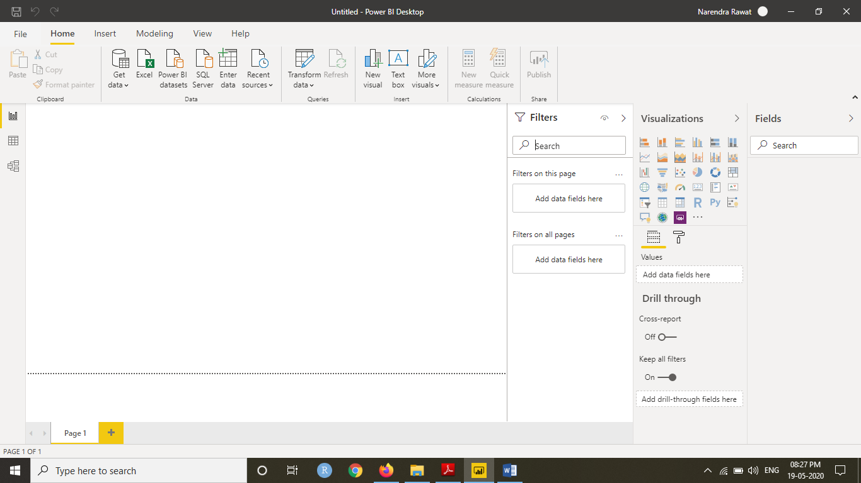

**Question 2: Description about PowerBi Features**

**Report View:**

Power BI is an easy tool to create reports providing dynamic perspectives and insights into your data. Power BI also has more advanced features in Power BI Desktop. With Power BI Desktop, create advanced queries, mashup data from multiple sources, create relationships between tables, and more.

Power BI Desktop includes a Report view, where you can create any number of report pages with visualizations. Report view in Power BI Desktop provides a similar design experience to the report's editing view in the Power BI service. You can move visualizations around, copy and paste, merge, and so on.

The difference between them is when using Power BI Desktop, you can work with your queries and model your data to make sure your data supports the best insights in your reports. You can then save your Power BI Desktop file wherever you like, whether it's your local drive or to the cloud.

For first look of Report view please refer to the above screen shot.

We can switch between **Report**, **Data**, and **Relationship** views by selecting the icons in the left-hand navigation pane:

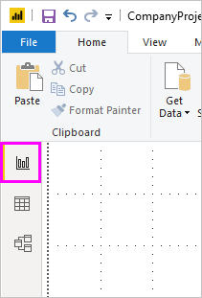

Once we added some data in the report view we can add many visualization



**Data View**

Data view helps us inspect, explore, and understand data in our Power BI Desktop model. It's different from how you view tables, columns, and data in Power Query Editor. With Data view, we are looking at our data after it has been loaded into the model.

**Note**

Since Data view shows data after it's loaded into the model, the Data view icon is not visible if all data sources are based on DirectQuery

When we are modeling our data, sometimes we want to see what's actually in a table or column without creating a visual on the report canvas. We might want to see right down to the row level. This ability is especially useful when you're creating measures and calculated columns, or we need to identify a data type or data category.

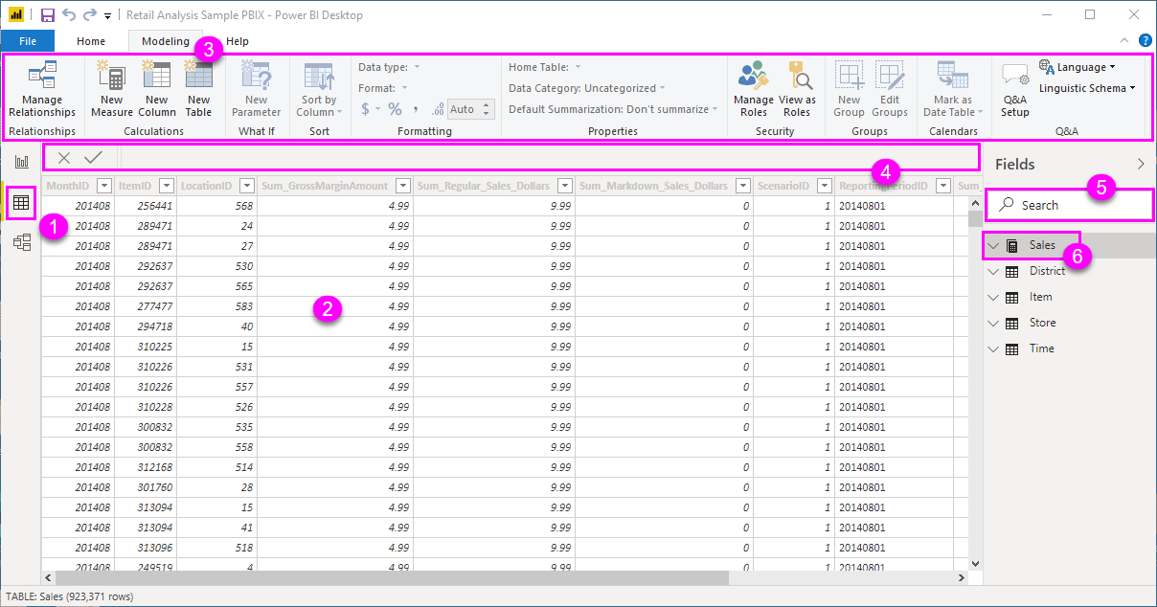

1. **Data view icon**. Select this icon to enter Data view.
2. **Data Grid**. This area shows the selected table and all columns and rows in it. Columns hidden from *Report* view are greyed out. You can right-click on a column for options.
3. **Modeling ribbon**. Here you can manage relationships, create calculations, change data type, format, data category for a column.
4. **Formula bar**. Enter Data Analysis Expression (DAX) formulas for Measures and Calculated columns.
5. **Search**. Search for a table or column in your model.
6. **Fields list**. Select a table or column to view in the data grid.

**Note**

When a Power BI model is created in a different culture than your current user interface, the search box will not appear in the Data view user interface for anything other than text fields. For example, this would apply for a model created in US English that you view in Spanish.

**Model View:**

Model view shows all of the tables, columns, and relationships in our model. This view can be especially helpful when our model has complex relationships between many tables.

Select the **Model** icon near the side of the window to see a view of the existing model. Hover your cursor over a relationship line to show the columns that are used.

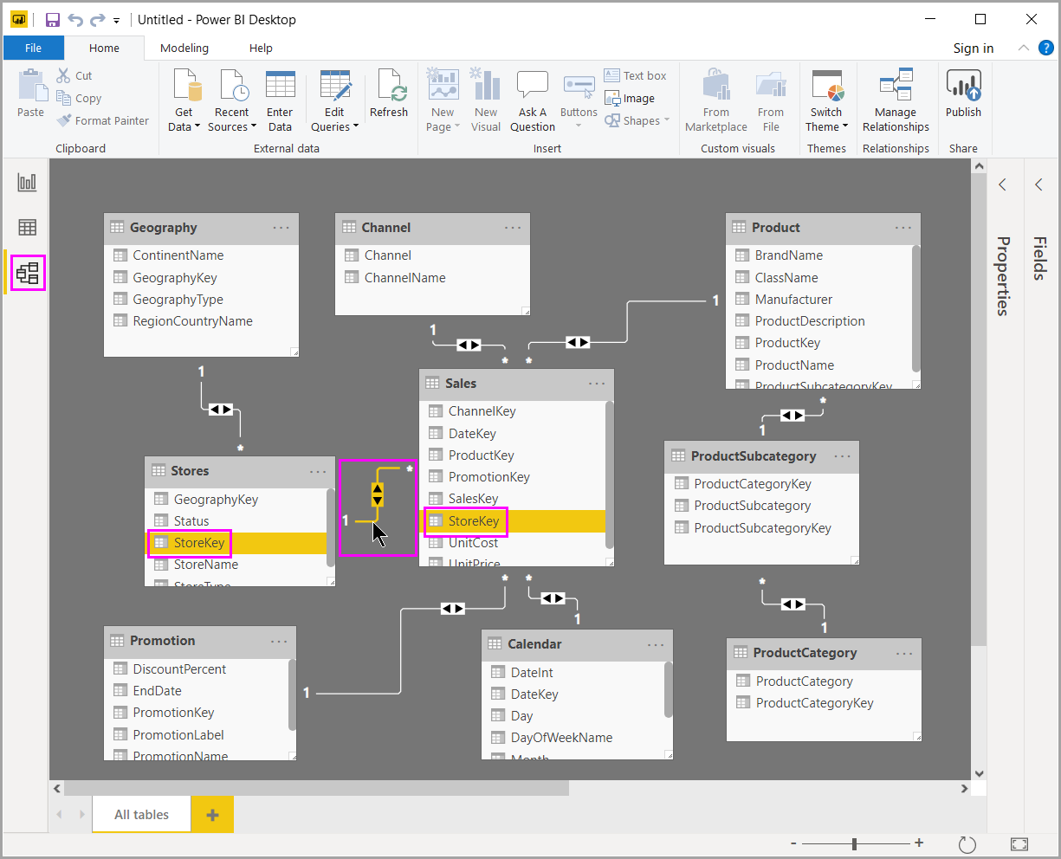

**Power Query Editor**

With **Power Query** in **Power BI** you can connect to many different data sources, transform the data into the shape you want, and quickly be ready to create reports and insights. When using Power BI Desktop, **Power Query** functionality is provided in the **Power Query Editor**.

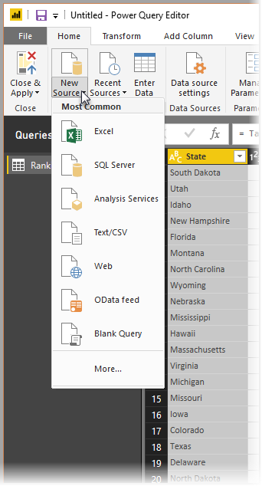

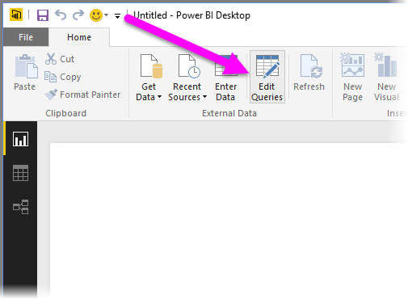

With no data connections, **Power Query Editor** appears as a blank pane, ready for data.

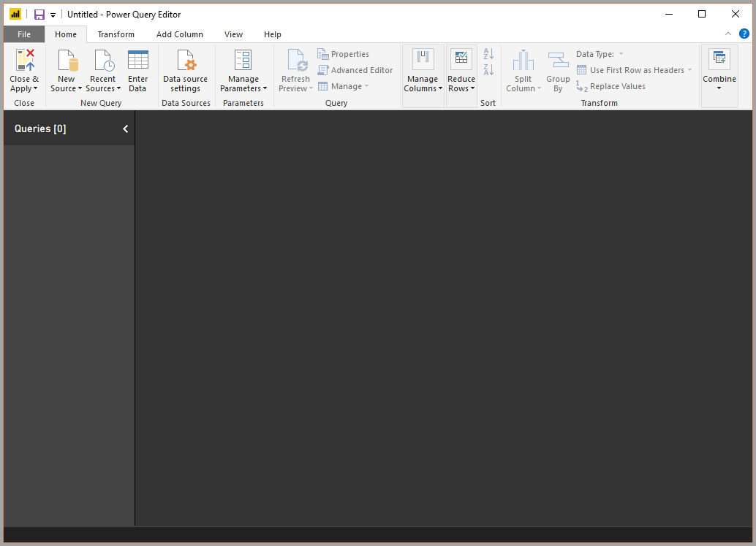

**Question 3:**

Microsoft Power BI is a cloud-based business intelligence and analytics service that provides a full overview of your most critical data. Connecting to all of your data sources, Power BI simplifies data evaluation and sharing with scalable dashboards, interactive reports, embedded visuals and more.

**Power BI Desktop**: This offering is free to any single user and includes data cleaning and preparation, custom visualizations and the ability to publish to the Power BI service.

• **Power BI Pro**: The Pro plan costs $9.99/user/month. It includes data collaboration, data governance, building dashboards with a 360-degree real-time view and the ability to publish reports anywhere. Users can try it a free trial for 60 days before purchasing the subscription.

• **Power BI Premium:** The Premium plan starts at $4,995 a month per dedicated cloud compute and storage resource.